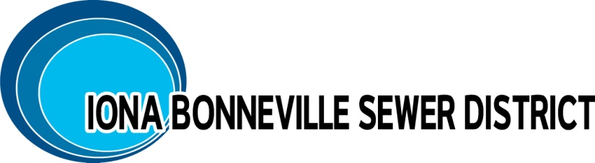

NOTICE IS GIVEN: The Board of Directors of the Iona Bonneville Sewer District shall hold a SPECIAL MEETING, Wednesday, October 22nd, 6:00 p.m..

Iona Bonneville Sewer District
3395 East Leihm Lane
Idaho Falls, Idaho

October 22nd, 6:00 p.m.

SPECIAL BOARD MEETING

- Work Meeting – Panorama Hills Permitting
- Executive Session: Idaho Code: 74-206 (1)(c) interest in real property

The next monthly meeting is scheduled for: Wednesday, November 19, 2025, at 6:00 p.m. at the District office and will be further confirmed at this board meeting.

When an item is placed on the agenda, it is understood that a discussion may be had and/or a decision may be reached by the Board of Directors for that agenda item.

Any person needing special accommodations to participate in the above noticed meeting should contact the Iona Bonneville Sewer District at 208-524-4545 or 3395 E. Leihm Lane, Idaho Falls, ID

