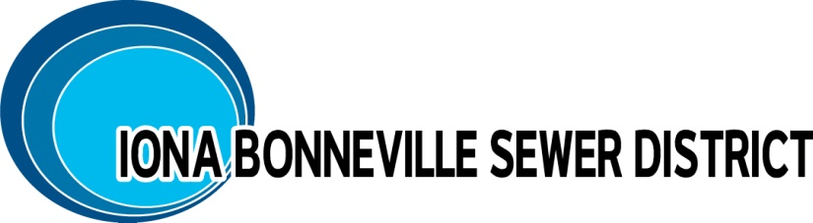
NOTICE IS GIVEN: The Board of Directors of the Iona Bonneville Sewer District shall hold a MONTHLY MEETING, Wednesday, November 19, 2025, at 6:00 p.m. at the office of the Iona Bonneville Sewer District located at 3395 East Leihm Lane, Idaho Falls, Idaho.

Iona Bonneville Sewer District
3395 East Leihm Lane
Idaho Falls, Idaho

November 19th, 6:00 p.m.

MONTHLY BOARD MEETING

- Action Item – Will Not Serve – Knowles (5229 E Lincoln Rd) & Simmons (2620 E Simmons Ln)
- Action Item - Panorama Hills Permitting
- Action Item – Extension of Sewer Main East 49th North Update and Discussion - MOU
- Action Item – Wastewater Treatment Facility Discussion and Update
- Action Item – Iona Road Manhole Relocation
- Action Item – 1st Street Sewer Main Update
- Action Item – IBSD Rate Review & Discussion
- Action Item – IBSD Annual Health Insurance Review
- Action Item – Scheduling of 2026 Board meeting dates
- Action Item – IBSD Holiday Schedule, Party & Bonuses
- Action Item – Additional Board Meetings: Investment Meeting Discussion & Approval (10/30/2025)
- Action Item – Approval of Minutes: 10/15/2025
- Action Item – Payment of Bills
- Executive Session: Idaho Code: 74-206 (1)(c) interest in real property

The next monthly meeting is scheduled for: Wednesday, December 17th, at 6:00 p.m. at the District office and will be further confirmed at this board meeting.

When an item is placed on the agenda, it is understood that a discussion may be had and/or a decision may be reached by the Board of Directors for that agenda item.

Any person needing special accommodations to participate in the above meeting should contact the Iona Bonneville Sewer District at 208-524-4545 or 3395 E. Leihm Lane, Idaho Falls, ID

