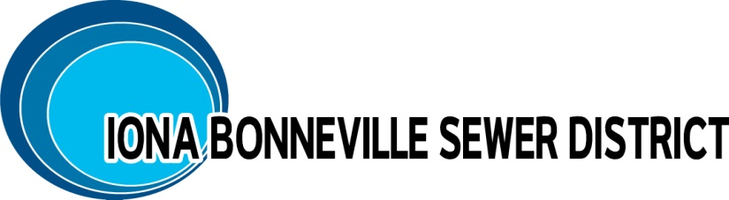
NOTICE IS GIVEN: The Board of Directors of the Iona Bonneville Sewer District shall hold a MONTHLY MEETING, Wednesday, January 21, 2025, at 6:00 p.m. at the office of the Iona Bonneville Sewer District located at 3395 East Leihm Lane, Idaho Falls, Idaho.

Iona Bonneville Sewer District
3395 East Leihm Lane
Idaho Falls, Idaho

January 21st, 6:00 p.m.

MONTHLY BOARD MEETING

- Action Item – Curlew/1st St De-annexation – Mountain West Engineering
- Action Item – Riviera Park Lift Station and Development Update
- Action Item – Extension of Sewer Main East 49th North Update and Discussion
- Action Item – Wastewater Treatment Facility Discussion and Update
- Action Item – Altura Update
- Action Item – IBSD Rate Review & Discussion – Forsgren & Associates
- Action Item – IBSD Year to Date Expense Update
- Action Item – Approval of Minutes: 12/17/2025
- Action Item – Payment of Bills
- Executive Session: Idaho Code: 74-206 (1)(b) employee evaluations

The next monthly meeting is scheduled for: Wednesday, February 18th, at 6:00 p.m. at the District office and will be further confirmed at this board meeting.

When an item is placed on the agenda, it is understood that a discussion may be had and/or a decision may be reached by the Board of Directors for that agenda item.

Any person needing special accommodations to participate in the above meeting should contact the Iona Bonneville Sewer District at 208-524-4545 or 3395 E. Leihm Lane, Idaho Falls, ID

