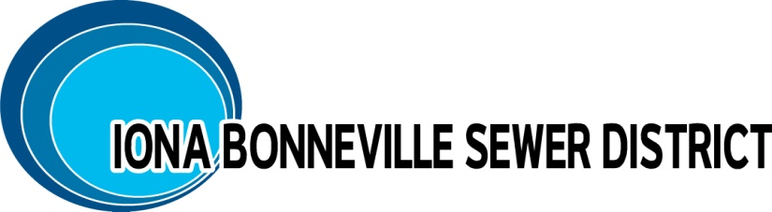
NOTICE IS GIVEN: The Board of Directors of the Iona Bonneville Sewer District shall hold a MONTHLY MEETING, Wednesday, February 18, 2025, at 6:00 p.m. at the office of the Iona Bonneville Sewer District located at 3395 East Leihm Lane, Idaho Falls, Idaho.

Iona Bonneville Sewer District
3395 East Leihm Lane
Idaho Falls, Idaho

February 18th, 6:00 p.m.

MONTHLY BOARD MEETING

- Action Item – Riviera Park Lift Station and Development Update
- Action Item – Wastewater Treatment Facility Discussion and Update
- Action Item – Bylaws and Policy Update – Grinder Pumps
- Action Item – Rental Property – 1684 Wildwood
- Action Item – Approval of Minutes: 12/17/2025
- Action Item – Payment of Bills

The next monthly meeting is scheduled for: Wednesday, March 18th, at 6:00 p.m. at the District office and will be further confirmed at this board meeting.

When an item is placed on the agenda, it is understood that a discussion may be had and/or a decision may be reached by the Board of Directors for that agenda item.

Any person needing special accommodations to participate in the above meeting should contact the Iona Bonneville Sewer District at 208-524-4545 or 3395 E. Leihm Lane, Idaho Falls, ID

