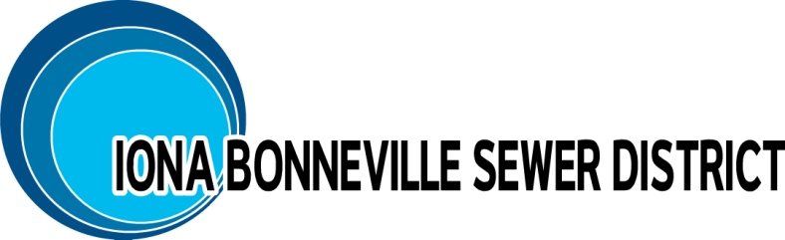

3395 E. Leihm Lane
Idaho Falls, Idaho 83401
Office - 208-524-4545
ibsd@sewerdistrict.com

Application for Sewer Connection

Commercial

Property Information:
Lot: Block: Section: Subdivision:
Service location (street address): Parcel ID:

Builder Information:
Last Name: First Name: MI:

Company:
Mailing Address:

Office#: Cell#: Email:

Owner Information: (If available or different from above)
Last Name: First Name: MI:

Company:
Mailing Address:

Phone#: Cell#: Email:

Requested Connection Information:
⁯ Commercial (i.e. Retail, Restaurant, etc.) ______________ ⁯ Employee#________
Connection Status: ⁯ New ⁯ Replacement
Connection: ⁯ Main ⁯ Stub-out
Connection Type: ⁯ Gravity ⁯ Force Main (Pressurized connection)
Connection Size: ⁯ 4-inch ⁯ Other______ (6-inch or greater requires Engineering)
Will a street need to be opened for the utility connection to be made: ⁯ Yes ⁯ No
Owner of the street or ROW that will be opened: ⁯ City ⁯ County ⁯ State

For IBSD Use

Date Application Submitted: ________________ IBSD # ______________
Served by Lift Station: ⁯ Class I ⁯ Class II ⁯ Class III
Is approval from DEQ required: ⁯ No ⁯ Yes (6-inch or greater connection)
Is a review by the IBSD Engineer required: ⁯ No ⁯ Yes (Main connection)?
IBSD received payment in full: ⁯ Yes ⁯ No Check#: _________
- Applicable fees ⁯ $1,850.00 ⁯ $2,850.00 ⁯ $3,650.00
⁯ $200 Main inspection ⁯ $582.00 City of Idaho Falls
- Estimated ERU___________
- Plan Checking Fee = $210 + #lots___ x $10.50 = $ ______

Applicant Signature: ______________________________________________________
Name Date

3395 E. Leihm Lane
Idaho Falls, Idaho 83401
Office - 208-524-4545
ibsd@sewerdistrict.com

Sewer Connection Checklist/Procedure
Commercial

If this project requires an extension of the sewer main please note the procedures in italics

- Fill out and return Application

- Application must be reviewed and approved by the Board at regular monthly meeting. Please note that additional approval by the Board may be required if conditions change after original Board approval. All work within IBSD requires approval by the Board of Directors.

- Submit drawings for review by IBSD appointed Engineer. Engineer requires two weeks for review process.
- Plan checking fees are due at this time (to be determined by Board).

- Submit plans to Idaho Falls for review and approval.

- Plans involving extension of the sewer main and/or lift station must be submitted to DEQ for approval.

- After approval from Idaho Falls and Engineer review IBSD will issue extension letter to DEQ stating project complies with requirements and IBSD will serve project. IBSD will own and operate the system after acceptance and one-year warranty period

- Development agreement with IBSD executed.

- Individual permit for each unit can be issued as the units are built out.

- Inform IBSD of construction schedule in advance of construction. Main line connections must be inspected - 2 business days (48 hours) advance notice required.
- Inspection fees are due prior to inspection ($200.00 per connection).

- Inform Engineer of construction schedule in advance of construction so that spot inspections can be performed.

- The following is a list of tests and inspections required for sewer main lines upon the completion of installation of lines but before the placement of asphalt and structural fill. All lines shall be cleaned and flow shut off just prior to testing. IBSD requires two business days’ notice for inspections.

    - Connection to IBSD sewer system.
    - Low Pressure Air test per Idaho Falls Standard Specifications section 704.03.
    - Deflection test per Idaho Falls Standard Specifications section 704.04.
    - Television Inspection per Idaho Falls Standard Specifications section 704.05 (allow one week for review).

- Developer’s Engineer certifies to IBSD that all construction meets IBSD approved standards and specifications and submits test results.

- City of Idaho Falls inspects lines with closed circuit television and accepts lines for maintenance.

- After placement of asphalt and structural fill the City of Idaho Falls will inspect manholes.

- As-Constructed drawings must be submitted to IBSD and the City of Idaho Falls as well as DEQ if approval is required. These drawings must be submitted in electronic form accompanied by plan sheet set of final plat.

- Once the sewer system is complete and developer has received conditional acceptance from IBSD a one-year warranty on all construction begins. Developer is responsible for the system during the one-year warranty and/or until final acceptance.

- Near the completion of the one-year warranty period (within 30-days of expiration) a televised review of the system will be performed to check for items of noncompliance. Any discrepancies are remedied by the developer before final acceptance. This review will include a closed-circuit television report by an IBSD approved contractor done at the developer’s expense.

As a reminder:

    - Prior to cutting into a road or disturbing any Right-of-Way the contractor (or owner) must contact the agency responsible for the maintenance of the ROW i.e. city, county, state, or private and obtain permission/permit to excavate in ROW.

    - Contractor (or owner) is also responsible to obtain permission from the local jurisdiction to limit lane access or close and detour a road. Contractor is responsible for all safety measures, cones, signs, flaggers, etc. required to maintain traffic safely through the construction area.

    - Connection should be made per City of Idaho Falls Standard Specifications standard drawing 700-5 and “Idaho Standard for Public Works Construction” standard drawing SD-511.

    - Inspection should be performed by qualified person or entity selected by the District who will submit an inspection report and picture.

    - Return any disturbed ROW to existing condition and repair roadway cuts per ISPWC standard details SD-301,302, & 303.

