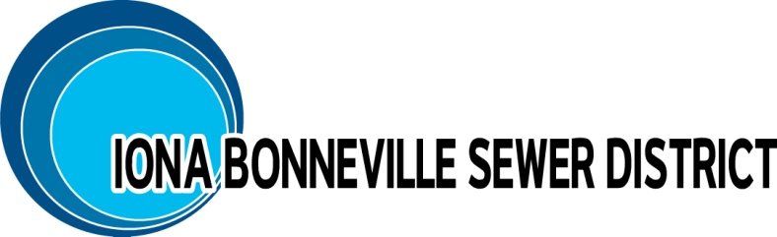

3395 E. Leihm Lane
Idaho Falls, Idaho 83401
Office - 208-524-4545
ibsd@sewerdistrict.com

Application for Sewer Connection

Single Residential

Property Information:
Lot: Block: Subdivision:
Service location (street address): Parcel ID:

Builder Information:
Last Name: First Name: MI:

Company:
Mailing Address:

Office#: Cell#: Email:

Owner Information (if available):
Last Name: First Name: MI:
Mailing Address:

Phone#: Cell#: Email:

Requested Connection Information:
⁯ Residential (in subdivision) ⁯ Residential (single, mainline connection subject to inspection fee)
Connection Status: ⁯ New ⁯ Replacement
Connection: ⁯ Main ⁯ Stub-out
Connection Type: ⁯ Gravity ⁯ Force Main (Pressurized connection)
Connection Size: ⁯ 4-inch ⁯ Other______ (6-inch or greater requires Engineering)
Will a street need to be opened for the utility connection to be made: ⁯ Yes ⁯ No
Owner of the street or ROW that will be opened: ⁯ City ⁯ County ⁯ State

For IBSD Use

Date Application Submitted: ________________ IBSD # ______________
Served by Lift Station: ⁯ Class I ⁯ Class II ⁯ Class III
Is approval from DEQ required: ⁯ No ⁯ Yes (6-inch or greater connection)
Is a review by the IBSD Engineer required: ⁯ No ⁯ Yes (Main connection)?
IBSD received payment in full: ⁯ Yes ⁯ No Check#: _________
Applicable fees ⁯ $1,850.00 ⁯ $2,850.00 ⁯ $3,650.00
⁯ $200 Main inspection ⁯ $582.00 City of Idaho Falls

Applicant Signature: ______________________________________________________
Name Date

3395 E. Leihm Lane
Idaho Falls, Idaho 83401
Office - 208-524-4545
ibsd@sewerdistrict.com

Connection Checklist

Single Residential

- Fill out and return Application. Show sketch of connection if mainline connection is needed.

- Pay Connection Fee prior to construction with mainline inspection fee if applicable.

- Project reviewed by IBSD Engineer if required. (Applicable to single residence not in subdivision)

- Inform IBSD of construction schedule in advance of construction. Main line connections must be inspected - 2 business days (48 hours) advance notice required.

- A one-year warranty is required on service connections and road repair and begins upon IBSD acceptance.

As a reminder:

    - Prior to cutting into a road or disturbing any Right-of-Way the contractor (or owner) must contact the agency responsible for the maintenance of the ROW i.e. city, county, state, or private and obtain permission/permit to excavate in ROW.

    - Contractor (or owner) is also responsible to obtain permission from the local jurisdiction to limit lane access or close and detour a road. Contractor is responsible for all safety measures, cones, signs, flaggers, etc. required to maintain traffic safely through the construction area.

    - Connection should be made per City of Idaho Falls Standard Specifications standard drawing 700-5 and “Idaho Standard for Public Works Construction” standard drawing SD-511.

    - Inspection should be performed by qualified person or entity selected by the District who will submit an inspection report and picture.

    - Return any disturbed ROW to existing condition and repair roadway cuts per applicable standards.

